I. Undergraduate Major Proposal: ASL Access, Equity and Inclusion
Degree: Bachelor of Arts in ASL Access, Equity and Inclusion
Implementation date: Fall 2024
Unit administering the Major Program: The Center for Languages Literatures and Cultures, and then when the Center for ASL and Deaf Equity is established (in 2024 or early 2025) they will take over. Since Centers are not degree-granting units and a major requires at least one faculty member to operate, the College will fund the hiring of two Professors of Teaching and a faculty member assigned to a TIU. The faculty member would have a 50% appointment with the CLLC to teach in the major program and/or the certificate program and oversee the major and minor curricula. In addition, there are two future goals that this faculty member could work toward if desired: 1) develop a teacher training manual based on the curriculum offered for the certificate, 2) develop an online Master’s program in ASL teaching.
Several possible candidates to target have been identified by the ASL instructional team.
- Dr. Joseph Hill: Rochester Institute of Technology
Associate Professor in the Department of ASL and Interpreting Education, Associate Director of the Center on Culture and Language, and Assistant Dean for Faculty Recruitment and Retention
- Dr. Octavian Robinson: Gallaudet University
Associate Professor of Deaf Studies; Deaf Historian
- Dr. Raychelle Harris: True+Way ASL (formerly at Gallaudet University)
Senior Adjunct Faculty Department of Language, Education, & Culture
- Dr. Naomi Sheneman: University of Northern Colorado
Curriculum Developer in Department of ASL & Interpreting Studies (focus on ethics in interpreting work)
- Dr. Rezenet Moges-Riedel: California State University, Long Beach
Assistant Professor in ASL Linguistics and Deaf Cultures
- Dr. Becky Brooks: Ohio University
Associate Professor of Instruction & ASL Program Coordinator
- Dr. Kenneth DeHaan: Gallaudet University
Assistant Professor & Masters of ASL Education Program Director
- Dr. Lissa Ramirez-Stapleton: California State University Northridge
Associate Professor at California State University Northridge in the Deaf Studies Department and core faculty in the Educational Leadership and Policy Studies Program
- Dr. Franklin Jones, Jr. (PhD): Boston University
Faculty Lecturer: Wheelock College of Education & Human Development
- Aimee Sever-Hall (PhD Candidate): St. Catherine University
Asst. Professor (TT), Department Chair: ASL & Interpreting Dept.
- Dr. Amy Rowley: California State University, East Bay
Professor & Coordinator of ASL Program
- Dr. Stephanie Cawthorn: University of Texas at Austin
Professor & Director of the Collaborative for Access & Equity

II. Rationale
A. Rationale/Purpose of the major, Data, Resources
ASL is experiencing a boom in enrollments at OSU and across the country. From Fall 2022 to the present the increase in enrollment in 1101-1103 prompted the hiring of 8 additional full-time instructors and three adjuncts. It is important to point out that prior to this time, many students had not been able to get into ASL 1101-1103 courses until their Junior year and thus did not have time to declare the minor. Moreover, the practice prior to hiring new staff had always been to ensure that the 1101-1103 GE courses were offered, so the minor courses had limited offerings. With the recent investment in instructors, our ability to reach underclassmen has grown and the ASL Studies minor has healthy enrollments, suggesting that now is the time to develop a major. The minor was approved in the Spring of 2020 and in Autumn 2020 students could declare the minor. The first year the minor was offered 9 students declared the minor and 7 graduated with the minor by the end Spring of 2021. Since then, 84 students have declared the minor.
The courses included in the Minor are the following:
- ASL 2104: American Sign Language Conversational Discourse
- ASL 3105: American Sign Language Literature
- ASL 3350: American Deaf Arts and Literature
- ASL 4189S: Service-Learning Within Deaf Communities

During academic year 2022- 2023, the ASL program along with the Center for Languages Literatures and Cultures applied for and received the ASC Undergraduate Student Success Grant in the amount of $3000.00 to extend the placements of ASL Service-Learning Course (ASL 4189s) into the month of May for students interested in continuing with their experiential learning. The grant was awarded to ASL and the CLLC by the College of Arts and Sciences Career Success Office. The grant was used to provide students with a stipend for hours worked in May of 2023 while continuing at their service-learning community partners and expanding their language growth, continuing their involvement in the Deaf community, and furthering their development of intercultural awareness. Another part of the grant was for all students enrolled in the ASL 4189s course to receive guidance from the ASC Career Success Office on how to include experiential learning opportunities on their resumes and how to navigate Handshake. Students interested in the extension of experiential learning applied and were vetted with the assistance of their course instructors. At the completion of the grant, 23 students had worked throughout the semester on their resumes and Handshake with the ASC Career Success Office. Three students were selected to continue with their experiential learning and during May 2023 they worked a total of 124 hours with 3 Deaf community partners. The ASL & CLLC have applied to the ASC Undergraduate Student Success Grant for the academic year 2023 – 2024 to continue the development of the expanded experiential learning opportunities and connecting students to resources within the College.
We continue to try to hire ASL instructors, but we have had difficulty finding qualified teaching staff, which is a foundational reason for the creation of the Certificate for ASL Teacher Training that we are also proposing. The certificate will be part of the Center for ASL Teacher Training and Deaf Equity, which has been approved and funded by the College. The major goes hand-in-hand with the certificate (with some courses overlapping), since we recognize that a center for ASL teacher training at an institution that does not have a major in ASL, at least in progress, creates an optics problem.

B. Benefits of the major
1. Improve access, opportunities, diversity, and increase OSU's presence as a deaf-welcoming institution
As a land-grant institution, Ohio State aims to improve the lives of individuals within our state with research-based programming and educational resources. Likewise, developing an ASL Center for Teaching and a major will improve access, opportunities, diversity, and increase OSU's presence as a deaf-welcoming institution. Historically, there have been significant gaps in achievement outcomes that have drastic and lasting consequences for deaf people worldwide. Nationally deaf people, compared to their hearing peers, are falling short with a 23% employment gap, a 6.5% high school completion gap, a 14.7% bachelor's completion gap, and an 8% gap in postsecondary enrollment (Garberoglio et al., 2019). Ohio falls even further below the deaf national employment gap average, 23.8%, the high school completion gap, 7.6%, and the bachelor's completion rate, 15.6% (Garberoglio et al., 2017), some disturbing facts despite Ohio's many thriving deaf communities (e.g., Columbus, Cincinnati, Cleveland, Dayton, Youngstown).
Within the last three years, deaf enrollment at OSU has seen an uptick from thirteen students in 2019 to twenty-three students in 2022. Perhaps attributed to increased shared financial support for college and university training services from both in-state and out-of-state vocational rehabilitation services (e.g., Ohio College2Careers). Recently, Governor DeWine announced an additional $2.1 million in additional support for college students with disabilities (State of Ohio Office of the Governor, 2022).
A need still exists to interrogate further the educational barriers that limit deaf people's access to higher education (Eckard, 2019; 2020; 2021a; 2021b). Such barriers as, who defines what academic, social, and noncognitive skills look like for a deaf person, and systemic hearing dominant ideologies (Eckard, 2021a). Searching beyond the static structures grounded in one reality, the hearing way, to a constructivist viewpoint based on lived experiences, the deaf way (Eckard, 2021b). A deaf-welcoming academic model will allow opportunities for deaf students to flourish.
Deaf educational disparities reach far beyond the capabilities of higher education. Nevertheless, it is higher education's responsibility to help fight these battles in our community and reimagine greater possibilities committed to more solutions than problems. Solutions that center on deaf people as a linguistic and cultural minority and explore ways to bridge the divide between education and employment (Eckard, 2019; 2020; 2021a; 2021b). Moreover, re-envisioning how to serve and support practices that foster equity and inclusion of more deaf students in postsecondary settings (Eckard, 2019; 2020; 2021a; 2021b).
References
Eckard, T. (2019). Deaf culture in hearing higher education institutions. [Unpublished manuscript]. The Ohio State University.
Eckard, T. (2020). Where are all the deaf college students, and are we ready for them? [Unpublished manuscript]. The Ohio State University.
Eckard, T. (2021a). Deaf and hard of hearing achievement gaps: Centering self, experiences, and implications for advancing college readiness praxis [Unpublished manuscript]. The Ohio State University.
Eckard, T. (2021b). Can you see me? Centering deaf college students' cultural and linguistic identity development [Unpublished manuscript]. The Ohio State University.
Garberoglio, C. L., Cawthon, S., & Sales, A. (2017). Postsecondary Achievement of Deaf People in Ohio: 2017. Washington, DC: U.S. Department of Education, Office of Special Education Programs, National Deaf Center on Postsecondary Outcomes.
Garberoglio, C. L., Palmer, J. L., Cawthon, S., & Sales, A. (2019). Deaf people and educational attainment in the United States. National Deaf Center on Postsecondary Outcomes.
State of Ohio Office of the Governor. (2022, August 24). Governor DeWine announces $2 million additional support for college students with disabilities. https://governor.ohio.gov/media/news-and-media/governor-dewine-announces-2-million-additional-support-for-college-students-with-disabilities-08242022

2. Lack of ASL Majors in Ohio and around the country
a. Terminology
Before examining the data (shown in Tables 1 and 2), the following are short definitions of the different types of ASL programs offered at institutions of higher education.
ASL and ASL Studies Programs. ASL and ASL Studies programs (AA, BA) programs focus on the study of American Sign Language (ASL) as a language, including its grammar, syntax, and vocabulary with coursework in ASL, ASL linguistics, and ASL literature. Additional coursework may include deaf history, deaf culture, and the many unique features of the deaf community. Students will be able to use ASL in informal conversations but may not develop advanced fluency. The new perspectives, knowledge and skills developed in these ASL and ASL Studies programs prepare students to apply linguistic understanding and intercultural competence when interacting and working with the deaf community in such domains as architecture and design, the arts, business, criminology, journalism, medicine, public policy, service industry, social work, sociology, and vocational rehabilitation. These programs can also provide foundational knowledge and skills for students who pursue professions requiring advanced training, degrees, and licensure such as audiology, speech and language pathology, ASL education, deaf education, special education, linguistics research, occupational therapy, and psychology.
ASL Education Programs. ASL Education programs (BA, MA) include coursework in advanced ASL linguistics, ASL teaching methods, ASL curriculum development & design, assessment of ASL skills, professional issues in teaching ASL, supervised classroom teaching practicum and internships. Programs that lead to K-12 instruction may also include coursework in child development and classroom management. Many programs require applicants to be fluent in ASL. Graduates are expected to have native or near-native fluency. The knowledge and skills developed in these ASL education programs prepare students to teach ASL in community centers, some private schools, and post-secondary settings. K-12 schoolteachers of heritage language learners or within a world language program must pass their state’s licensing exams.

ASL - English Interpreting Programs. ASL - English Interpreting programs (AA, BA, MA) include coursework in advanced ASL, ASL linguistics, deaf history, deaf culture, deaf-blind interpreting, advanced and specialized interpreting (artistic, educational, legal, medical, religious), interpreting ethics, etiquette, cultural mediation, and multiple supervised interpreting practicums. Students are expected to participate in ASL and deaf community events and activities outside of class time. The knowledge and skills developed in these interpreter training programs prepare students to work as ASL-English interpreters in a variety of settings. Bachelor's programs include advanced ASL courses that help students become more fluent. To become nationally certified, students must pass the Registry of Interpreters for the Deaf exam.
Deaf Studies Programs. Deaf Studies programs (certificates, AA, BA, MA) take a broader approach than ASL Studies programs by examining deaf communities from multiple perspectives. In addition to ASL courses, Deaf Studies programs may offer courses on topics such as deaf history, deaf culture, deaf identity, deaf art and literature, and issues of concern to the deaf community including deaf education practices, dynamics of oppression, disability studies, intersectionality, advocacy, and public policy. Fundamental education in the historical, sociological, and cultural aspects developed in these deaf studies programs provide cultural and linguistic understanding by examining the experiences of deaf and hard-of-hearing people from a variety of perspectives. The knowledge and skills developed in deaf studies programs prepare students to work and advocate from a position of allyship in deafness-related agencies and organizations, independent living centers, historical archiving and curating, and vocational training services. These programs can also provide foundational knowledge and skills for students who pursue professions requiring advanced training, degrees, and licensure such as deaf education, ASL education, social work, and law.
While there is some overlap between ASL Studies and Deaf Studies programs, ASL Studies is typically more focused on the language itself, while Deaf Studies is more focused on the Deaf community as a whole. The proposed major straddles the ASL Studies and Deaf Studies categories, and is therefore designated ASL and Deaf Studies major with a focus on access, equity and inclusion.

b. Data ASL majors in the Big Ten and around the country
Table 1. Big Ten Institutions
BIG TEN  Institution | Type of Program
Indiana University-Bloomington | ASL Minor
University of Illinois | none  Only 2 ASL courses offered through residence halls
University of Iowa | ASL Minor
University of Maryland | none
University of Michigan | none  Only 4 courses offered through living-learning community (classes do NOT satisfy the language requirement)
Michigan State University | none
University of Minnesota | Deaf Studies Minor
University of Nebraska-Lincoln | none
Northwestern University | none
Penn State University | none  4 ASL courses + 1 Deaf Culture course offered
Purdue University | ASL & Deaf Studies Minor
Rutgers University | none  Only 2 ASL courses offered
University of Wisconsin – Madison | none  Only 1 course of combined ASL & Manually Coded English

Table 2. Bachelor’s Degree Programs
Institution | Type of Bachelor’s Degree Program
Bloomsburg University (Pennsylvania) | ASL - English Interpreting
Boston University (Massachusetts) | Deaf Studies
California State University-Northridge (California) | ASL - English Interpreting  Deaf Studies
University of Connecticut (Connecticut) | ASL Studies (ASL - English Interpreting concentration) or (Deaf Studies concentration)
Framingham State University (Massachusetts) | ASL  ASL - English Interpreting (concentration)  Deaf Studies (concentration)
Gallaudet University (Washington, DC) | ASL
Gardner-Webb University (North Carolina) | ASL Studies
University of Houston (Texas) | ASL - English Interpreting
Idaho State University (Idaho) | ASL - English Interpreting
Indiana University-Purdue University Indianapolis  (Indiana) | ASL - English Interpreting
Kent State University (Ohio) | ASL  ASL - English Interpreting  Deaf Education
Keuka College (New York) | ASL
*Lamar University (Texas) | ASL: K-12 Education Track  ASL: Interpreting Track  ASL: Advocacy Track
Liberty University (Virginia) | ASL - English Interpreting
*Madonna University (Michigan) | ASL +  ASL - English Interpreting
McDaniel College (Maryland) | ASL Studies
Mount Aloysius College (Pennsylvania) | ASL - English Interpreting
University of North Florida (Florida) | ASL - English Interpreting
University of Northern Colorado (Colorado) | ASL - English Interpreting
Northeastern University (Massachusetts) | ASL Studies
University of Rochester (New York) | ASL
Sacramento State University (California) | Deaf Studies
Sam Houston State University (Texas) | ASL Studies
St. Catherine University (Minnesota) | ASL  ASL - English Interpreting
University of South Florida (Florida) | ASL- English Interpreting and Deaf Studies, with ASL Interpreting Concentration
Towson University (Maryland) | Deaf Studies
*Utah Valley University (Utah) | ASL Education (7-12)  ASL - English Interpreting  Deaf Studies
Valdosta State University (Georgia) | ASL - English Interpreting ASL Living Learning Community
Western Oregon University (Oregon) | ASL Studies  ASL Living Learning Community
William Woods University (Missouri) | ASL - English Interpreting
University of Wisconsin – Milwaukee (Wisconsin) | ASL Studies  Also offer:Study Abroad, ASL Living Learning Community
Wright State University (Ohio) | ASL - English Interpreting

c. Data summary
Among the Big Ten institutions, there are five ASL-related minors. Ohio State offers an ASL Studies Minor, The University of Minnesota offers a Deaf Studies Minor, Purdue offers an ASL and Deaf Studies Minor, and the University of Iowa and Indiana University (Bloomington) offer an ASL minor. Around the country thirteen institutions offer a Minor – two in Deaf Studies, ten in ASL, and one in ASL-English Interpreting. In Ohio, Kent State also offers a minor in ASL studies.
NOTE: There are no ASL and Deaf Studies majors in the Big Ten. Thirty-three institutions around the country have a major (BA) degree. There are 20 ASL-English Interpreting BAs, 14 ASL/ASL Studies, four Deaf Studies, one Deaf Education, one ASL Advocacy, and two ASL K-12 Education. The Gallaudet University ASL BA includes two required courses in ASL instruction and an elective internship which can include teaching or tutoring. In Ohio, Wright State has an ASL-English Interpreting Major, whereas Kent State has a major with three tracks: ASL, ASL-English Interpreting, Deaf Education (K-12 Deaf/HoH students). The two ASL K-12/7-12 ASL Education programs are in Texas and Utah respectively.
d. Conclusions
The data suggest that Ohio State will have the first ASL and Deaf Studies major in the Big Ten and when combined with the Center for ASL Teacher Training and Deaf Equity and the Certificate in Teacher Training, we will be a premier location for ASL studies, an honor currently bestowed on Gallaudet University and the University of Northern Colorado, which also have MA programs. (Note that the next step, after the Center, Certificate and Major are running smoothly, will be to develop a Masters program.)

C. Career opportunities, opportunities for graduate or professional study, licensure or certification available to graduating majors
Graduates from the ASL and Deaf Studies major would be strong candidates for positions requiring engagement within the Deaf community including at residential schools (administration, human resources, student life, teacher’s aide), advocacy organizations and social service agencies (Deaf community services centers, domestic violence agencies, support services for deaf people with intellectual and developmental disabilities, job coaches), nursing homes for the Deaf, Students will develop intercultural sensitivity, cultural awareness, and an ability to communicate with diverse populations -- assets in any profession, including community organizing, hospitality, human resources, journalism, law enforcement, non-profit sector, performing arts, politics (lobbying and legislation), and public health to name a few.
The major provides a foundation for students to apply their knowledge and skills as they pursue graduate or professional study opportunities in such various fields of study as ASL Education, Audiology, Deaf Education, Disability Rights, Early Childhood Education, Interpreting, Law, Linguistics, Medicine, Mental Health Counseling, Nursing, Occupational Therapy, Psychology, Social Work, Speech and Language Pathology, and Vocational Rehabilitation Counseling.
To help students contextualize their work in ASL, they are required to take the two-hour workshop: World Languages Skills and Competencies, which is offered every semester through the Center for Languages Literatures and Cultures. During this workshop, students learn about the transferable skills that they have developed by learning a new language and representative from Career Services comes to explain to students how to express these skills on their resumes and in interviews. Other majors that also require the workshop for their majors: all the French majors, all the Italian majors, Romance Studies major.

III. Goals/Objectives and Evaluation of the Major
A. Goals and objectives
Goal A: Language proficiency. Students will demonstrate proficiency in ASL.
Expected learning outcome 1. By the end of the ASL and Deaf Studies major, students will be able to achieve at least intermediate proficiency level as described by the Sign Language Proficiency Interview (SLPI:ASL) or least a 2 on the ASL Proficiency Interview (ASLPI).
Goal B: Intercultural competence. Students have the attitudes (respect, openness, curiosity), knowledge (of self, culture, sociolinguistic issues) skills (listen, observe, interpret, analyze, evaluate, and relate), and qualities (adaptability, flexibility, empathy and cultural decentering) in order to behave and communicate effectively and appropriately to achieve their goals to some degree in any context.
Expected learning outcome 1. By the end of the ASL and Deaf Studies major, students will be able to describe and critique issues of marginalization and intersectionality in deaf communities such as race, gender, sexual orientation, and family dynamics.

Expected learning outcomes 2. By the end of the ASL and Deaf Studies major, students will be able to identify and critique issues of power, privilege, oppression, exclusion and intercultural competence.

Goal C. Cultural and historical knowledge. Students will understand the history and culture of the Deaf community in the United States.
Expected learning outcome 1. By the end of the ASL and Deaf Studies major, students will be able to describe and analyze literary and artistic productions created by Deaf individuals.
Expected learning outcome 2. By the end of the ASL and Deaf Studies major, students will be able to explain the history and culture of American deaf communities and organizations.

B. Assessment methods associated with each objective
Goals and ELOs | Assessment methods
Goal A. Language proficiency
Students will demonstrate proficiency in ASL
ELO 1. Students will be able to achieve at least intermediate proficiency level as described by the Sign Language Proficiency Interview (SLPI:ASL) or least a 2 on the ASL Proficiency Interview (ASLPI). | Direct: Students who are one or two courses away from finishing the major volunteer to take the SLPI every three years if funding is available. Students who volunteer will receive a $35 gift card.  The cost to take the SLPI: ASL interview is $150. The evaluation provided by the Ohio School for the Deaf in Columbus, Ohio is offered remotely or in person by contacting the SLPI Coordinator at slpi@osdb.oh.gov. The cost to take the ASLPI interview is $165 and $20 may be owed to a proctor. It is offered remotely or in person at Gallaudet University https://www.gallaudet.edu/the-american-sign-language-proficiency-interview/aslpi/  If funding is not available, a member of the ASL program will interview the volunteers and evaluate the students to the best of their ability in relation to the requirements of the professional proficiency interviews.  Indirect: Ever year a survey will be given to graduating majors which will ask students to rate their skills from 1-5 (5 being high)
Goal B. Intercultural competence. Students have the attitudes (respect, openness, curiosity), knowledge (of self, culture, sociolinguistic issues) skills (listen, observe, interpret, analyze, evaluate, and relate), and qualities (adaptability, flexibility, empathy and cultural decentering) in order to behave and communicate effectively and appropriately to achieve their goals to some degree in any context.
ELO 1. By the end of the ASL and Deaf Studies major, students will be able to describe and critique issues of marginalization and intersectionality in deaf communities such as race, gender, sexual orientation, and family dynamics. | Direct:  Program Assessment test created on Carmen. Alternate years (with goal C) students who have finished all or all but one of their courses required for the major will take the test. A question prompting a signed response (with the video uploaded) and an essay question related to this ELO will be created by the instructor of the 4000-level course: ASL Accessibility and Social Justice. A rubric will be created in Carmen and the test will be rated by the director of undergraduate studies and the Education Program Specialist. Students who are not at the end of the major will have a different test.  Indirect: Every year a survey will be given to graduating majors which will ask students to rate their skills from 1-5 (5 being high)
ELO 2. By the end of the ASL and Deaf Studies major, students will be able to identify and critique issues of power, privilege, oppression, exclusion and intercultural competence. | Direct: Program Assessment test created on Carmen. Alternate years (with goal C) students who have finished all or all but one of their courses required for the major will take the test. An essay question related to this ELO will be created by the instructor of the 4000-level course: ASL Accessibility and Social Justice. A rubric will be created in Carmen and the test will be rated by the director of undergraduate studies and the Education Program Specialist. Students who are not at the end of the major will have a different test.  Every three years in Spring: Essays from the World Languages Skills and Competencies workshop will be assessed for development of Intercultural Competence.  Indirect: Every year a survey will be given to graduating majors which will ask students to rate their skills from 1-5 (5 being high)
Goal C. Cultural and historical knowledge. Students will understand the history and culture of the Deaf community in the United States.
ELO 1. By the end of the ASL and Deaf Studies major, students will be able to describe and analyze literary and artistic productions created by Deaf individuals. | Direct: Program Assessment test created on Carmen. Alternate years with goal B students who have finished all or all but one or two of their courses required for the major will take the test. A question prompting a signed response (with the video uploaded) and an essay question related to this ELO will be created by the instructor of ASL 3105 – American Sign Language Literature. A rubric will be created in Carmen and the test will be rated by the director of undergraduate studies and the Education Program Specialist. Students who are not at the end of the major will have a different test.  Indirect: Every year a survey will be given to graduating majors which will ask students to rate their skills from 1-5 (5 being high)
ELO 2. By the end of the ASL and Deaf Studies major, students will be able to explain the history and culture of American deaf communities and organizations. | Direct: Program Assessment test created on Carmen. Alternate years with Goal B students who have finished all or all but one of their courses required for the major will take the test. Three short answer questions related to this ELO will be created by the instructor of the 3000-level course: American Deaf Culture and History. A rubric will be created in Carmen and the test will be rated by the director of undergraduate studies and the Education Program Specialist. Students who are not at the end of the major will have a different test.  Indirect: Every year a survey will be given to graduating majors which will ask students to rate their skills from 1-5 (5 being high)

C. Criteria to evaluate success
- 80% on the Carmen assessment tests.
- An average score on the IDI placing participating students in high Minimization or Acceptance.
- An average overall score between 4-5 on the exit survey.

D. Timeline to create and implement the assessment plan
We have 3.5 years to create the survey and the Carmen assessment test before there are any graduating majors. We would like to give the IDI to a sample of the first graduating seniors in order to set the baseline.
E. Use of outcomes data
The assessment plan will be input into Nuventive by the ASL APC.
The Carmen tests will rated by the Director of Undergraduate Studies and the Education Program Specialist.
The Intercultural Development Inventory will be paid for by the CLLC or ASL Center for Teacher Training and Deaf Equity. It will be administered by an IDI Qualified Administrator.
The annual data (with all student information removed) will be collected by the ASL APC and assessed by the Director of the ASL Center for Teacher Training and Deaf Equity and the Director of Undergraduate Studies to determine if adjustments need to be made to the program.

IV. Relationship to other programs/Benchmarking
- There are no other majors in the CLLC.
- There are no overlaps with other programs or departments.
- There are no cooperative arrangements with other institutions.
- There are no direct transfer opportunities with other institutions.
- This major was constructed by Janice M. Aski (Director of the CLLC), Kristin Wickham-Saxon (Director of Undergraduate Studies) and Tia Jones (Education Program Specialist). We were also the team to create the proposal for the ASL Center for Teacher Training and Deaf Equity and the Certificate for ASL Teacher Training.
- This proposal has not been submitted previously.
- Students will be drawn from the elementary ASL language sequence, which has exploded in enrollments in the last few years. We cannot exhaust the waiting list despite having hired eight new full-time instructors (we have a continuous job posting). Students will also be drawn from the existing minor which has ever increasing enrollments (see data in section II. Rationale, A). In addition, a central task of the ASL Center for Teacher Training and Deaf Equity is to recruit Deaf, Hard of Hearing and CODA students. We are working on a development plan to offer scholarships to these applicants and the center will provide support and advising.
- Concurrence from: Department of Speech and Hearing Science, Department of English, Department of Linguistics, Department of Teaching and Learning and World Languages Education in the College of Education and Human Ecology.

V. Student enrollment
We expect 10-15 students to enroll in the major each year for the first four years.
VI. Concurrences sought and obtained after two weeks
Sought: English, Speech and Hearing, Linguistics, World Language Education, Psychology
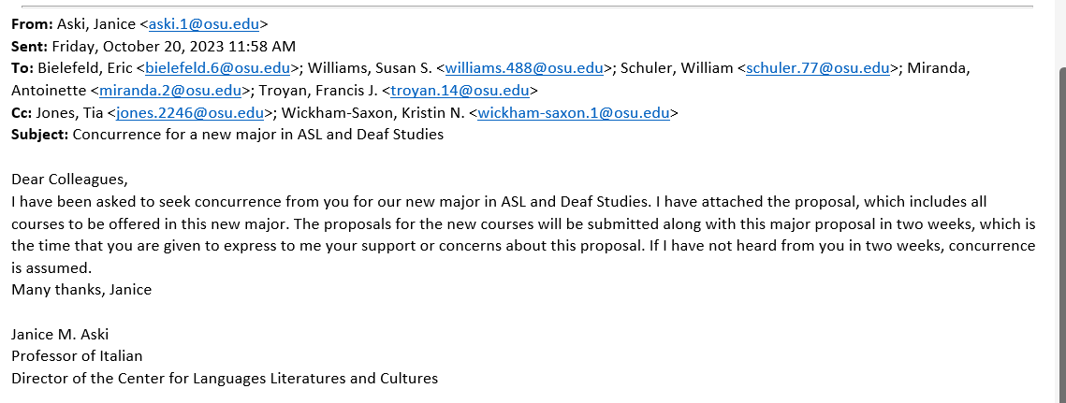

Obtained: Linguistics, English, Speech and Hearing, World Language Education
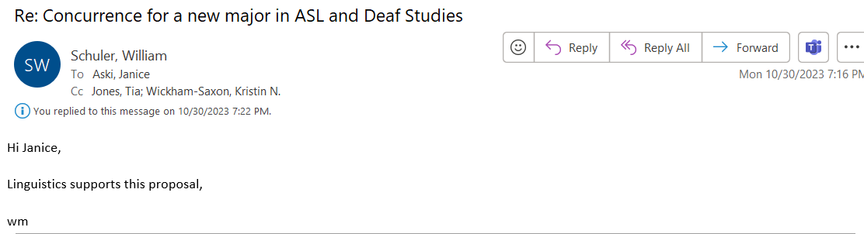

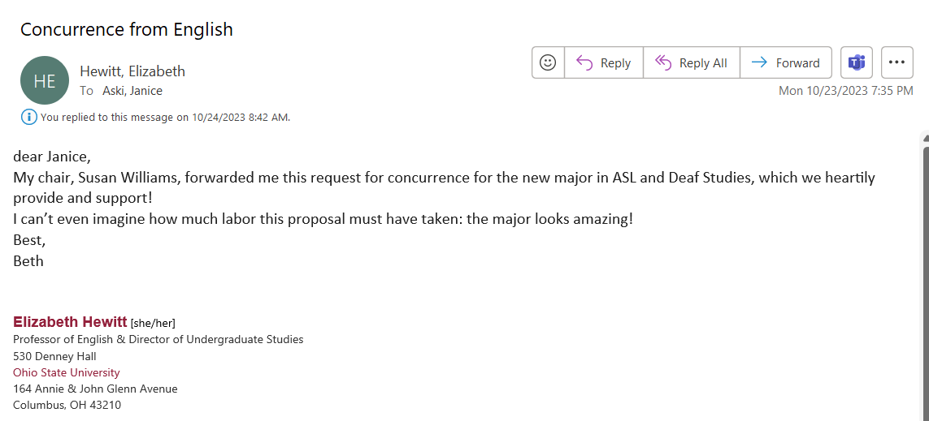
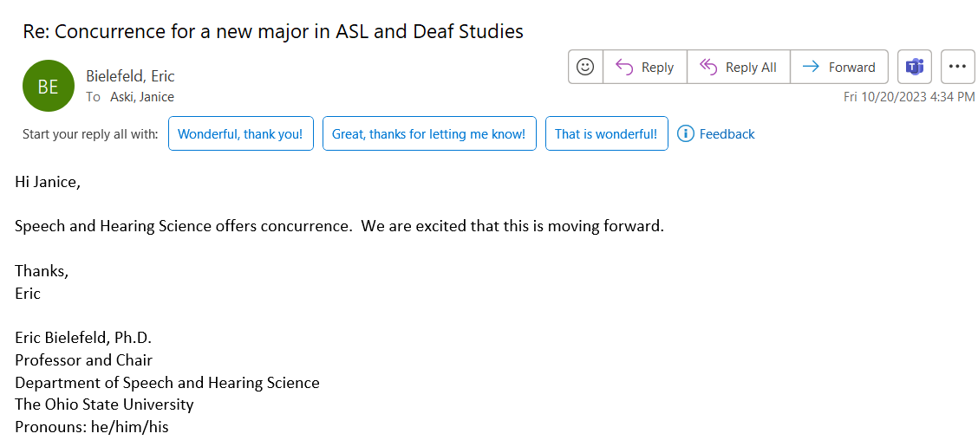
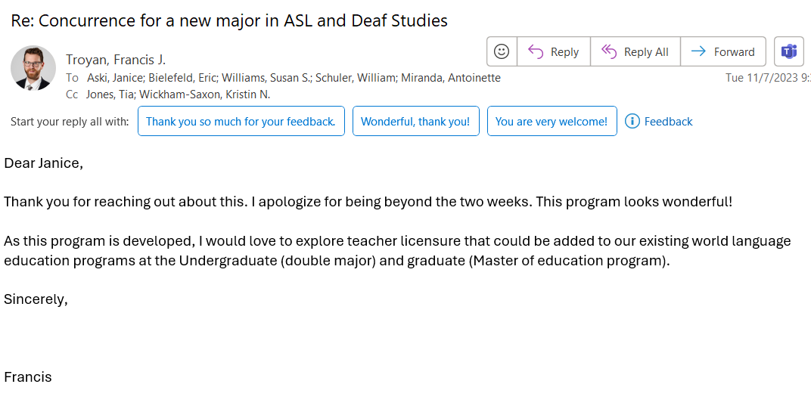
VII. Curricular requirements
- Curriculum advising sheet: Appendix A
- Courses: Appendix B
- Curriculum map: Appendix C
- There is no pre-major
- Minimum number of credits for completion of the major: 30
- Avg. number of credits expected: 30
- Four-year plan: Appendix D: We have spoken to Dean Renga and she is aware of the hiring needs (one lecturer in 2024-2025 and one in 2025-2026) and is supportive.
- Number of credits required from other departments: 1 credit of It 1198.71 Italian on the ground for students who will study abroad.
- Electives from other departments are not allowed.
- Other major requirements: none
- No accreditation will be sought.
- Facilities used: classrooms
- Additional university resources: one ASC advisor (We have spoken to Mary Ellen Jenkins and she is aware of this need.)

Appendix A
Curriculum Advising Sheet for Major in ASL Access, Equity and Inclusion

College of Arts and Sciences Major advising form
Center for Languages Literatures and Cultures
Major in ASL Access, Equity and Inclusion
Name (last, first, middle):
Phone:
Email:
Student ID:
Major: ASL Access, Equity and Inclusion
Degree sought: BA
Expected Date of Graduation:
Honors: _____ yes _____no
If completing more than one major, list all below and file a separate form for each:
1. ASL Access, Equity and Inclusion
2.
3.
Please note: No more than 15 transfer credit hours are allowed. Transfer credit hours include the prerequisites to the major.
Prerequisites (12 credits):
ASL 1101 ______ ASL 1102 _______ ASL 1103 _______

Semester taken Hours Grade
Part A: Required Courses (9 credits):
ASL 2104 __________ ________ _________
4000-level and above in ASL __________ ________ _________
4000-level and above in ASL __________ ________ _________

Part B: Electives. Only one class in English (E) permitted. (21 credits):
Choose a Course __________ ________ _________
Choose a Course __________ ________ _________
Choose a Course __________ ________ _________
Choose a Course __________ ________ _________
Choose a Course __________ ________ _________
Choose a Course __________ ________ _________
Choose a Course __________ ________ _________
Total Hours A and B ________
*Up to 9 credits of 5797 can count for the major.
For those who participated in the Program in Siena, Italy
Prerequisite: Italian 1198.71: Italian on the ground _________

Check whether this is ____ original or _____ revision.

World Language Skills and
Competencies Workshop Date of completion: ___________

Name of College Adviser: _____________________________________________________
Signature of College Adviser: __________________________________________________
Date: ______________________________________________________________________

Appendix B
Courses for Major in ASL and Deaf Studies
*For the four-year plan of offerings, see appendix D
This major will develop the knowledge and competencies for professionals to work in allyship within the deaf community. It will include courses taught in ASL except for one course that can be taught in English (if a student chooses). There are courses in the already existing ASL minor that can count for the major:
ASL 2104 - American Sign Language Conversational Discourse
ASL 3105 - American Sign Language Literature

Students in the major can choose one of the following existing minor courses offered in English:
ASL 3350 - American Deaf Arts and Literature
ASL 4189S - Service-Learning Within Deaf Communities

New courses being developed
ASL 4250 ASL Linguistics (3 credits) – (synchronous online)
Prerequisites: Two courses at the 3000 level or above
Through examination of major linguistic features of ASL and English, this course will focus on linguistic properties of ASL, including phonology, morphology, pragmatics, syntax, semantics, and socio-­‐linguistic variations in ASL with a concentration on how to teach major structural features of ASL to language learners. Satisfies embedded literacy: Data Analysis.
ASL 4350 ASL Accessibility and Social Justice (3 credits) – (synchronous online)
Prerequisites: One course at the 3000 level or above
This course explores ways that power, privilege, and oppression can impact equity and various aspects of accessibility. Though examining linguistic access and intercultural competence, students will consider how social justice can support allyship development to achieve common goals. Satisfies embedded literacy: Advanced Writing.
ASL 3104 - American Sign Language Conversational Discourse II (3 credits)
Prerequisite: ASL 2104 American Sign Language Conversational Discourse I
This course is designed to expand conversational discourse skills in ASL. Students will further develop receptive and expressive ASL communication skills by expanding on ASL vocabulary and ASL grammar. These skills will allow students the ability to engage in detailed conversations and more advanced topics.
ASL 4104 Presentational Language and Discourse Analysis (3 credits)
Prerequisite: One course at the 3000 level or above
Analysis of signed narratives, presentations, and discourse will explore the interlocuter’s register, sign choices (including socio-linguistic variations), phrasing, use of idioms, syntactical patterns, and pragmatics. Satisfies embedded literacy: Technology.
ASL 3650: American Deaf History and Culture (3 credits)
Prerequisite: ASL 2104 - American Sign Language Conversational Discourse
This course surveys the history and culture of deaf people in America. and Sign Language, its users, and their culture. It explores how the deaf community has been framed and describes the influence of leaders, events, and deaf-centric organizations.
ASL 3450: Life Experiences of Deaf Children (3 credits)
Prerequisite: ASL 2104 - American Sign Language Conversational Discourse
This course delves into the multifaceted experiences of deaf children, including language development, family dynamics, educational opportunities, communication strategies, and social-emotional development. Students will explore a variety of perspectives to learn about challenges and opportunities deaf children encounter from infancy to adolescence, and best practices for supporting deaf children in all areas of their development.
ASL 3750: Intersectionality and the ASL/Deaf community (3 credits)
Prerequisite: One course at the 3000-level or above
Examination of intersectionality and identity will include the experiences of American Black Deaf community, Black ASL, disability, immigrants, LGBTQIA community, multilinguals, and deaf-hearing blended families (CODA: children of deaf adults, SODA: sibling of deaf adults, GODA: grandchild of deaf adults, hearing parents of deaf children, and romantic partners).
ASL 5797 Study Abroad (Variable credit 3-9)
Up to 6 credits can count for the minor, up to 9 credits can count for the major.

One example of a program that counts for ASL 5797:

Program in Siena, Italy (3 credits)
Prerequisites: Italian 1198.71: Italian on the ground (predeparture course, 1 credit, asynchronous)

The Study Abroad for Deaf & Signers summer program offered by the Siena School for Liberal Arts in Italy offers a unique opportunity for ASL students to engage in a transnational Deaf-world. They will engage in linguistic and cultural experiences both in the classroom and in the community. The study abroad is open for American Deaf and ASL students and classes are taught by native Italian signers and speakers, so participants will be immersed in a multilingual and multicultural environment. Students will take 45 hours of Italian Sign Language (LIS), 30 hours of Italian Deaf Culture and History, and 15 hours of Italian spoken language during the three-week program. ASL students are required to have good academic standing and completion of ASL IV or equivalent from their home institution to enroll in the study abroad.
Deaf Studies - Academics - Siena School
We have completed the MOU with the Office of International Affairs. We are also collaborating with the Italian program, which is interested publicizing this program among their students and accepting credit for their work.
Appendix C
Curriculum Map for Major in ASL and Deaf Studies
B = beginning I = Intermediate A = Advanced
 | achieve intermediate or intermediate+ proficiency | describe and analyze literary and artistic productions created by Deaf individuals | describe and critique issues of marginalization and intersectionality in deaf communities | identify and critique issues of power, privilege, oppression, exclusion and intercultural competence | explain the history and culture of American deaf communities and organizations
Prerequisite and Required courses
1101 (GE) | B | B | B |  | B
1102 (GE) | B | B | B | B | B
1103 (GE) | B/I | B/I | B/I |  | B/I
ASL 2104 - American Sign Language Conversational Discourse | I | B | B | B/I | B
Elective courses in English
ASL 3350 - American Deaf Arts and Literature |  | I | B | B | I
ASL 4189S -  Service-Learning Within Deaf Communities |  |  | A | A | A
Elective courses in ASL
ASL 3104 - American Sign Language Conversational Discourse II | I/A | B | B | B/I | B
ASL 3105 - American Sign Language Literature | I/A | I/A | I | I | I
ASL 3350 - American Deaf Arts and Literature | I | A | I | B | I
ASL 3650 - American Deaf History and Culture (3 credits) | I | I | I | I | A
ASL 3450 -  Life Experiences of Deaf Children | I |  | A | A | I
ASL 3750 - Intersectionality and the ASL/Deaf community | A |  | A | A | I
ASL 4104 - Presentational Language and Discourse Analysis | A | I | I | I | I
ASL 4350 -  ASL Accessibility and Social Justice | A |  | A | A | I
ASL 4250 -  ASL Linguistics | A
ASL 5797 -  Study Abroad | I |  | B | I

Appendix D
Four-year plan for Major in ASL, Access and Equity
Year 1
Autumn | Credits |  | Spring | Credits
Writing & Informational Literacy GE | 3 |  | Historical & Cultural Studies GE | 3
Mathematical & Quantitative Reasoning | 3 |  | Natural Sciences GE | 4-5
Social & Behavioral Sciences GE | 3 |  | Literary, Visual, Performing Arts GE | 3
ASL 1101 | 4 |  | ASL 1102 | 4
Elective | 2 |  | GEN ED 1201 | 1
First-Year Survey | 1
TOTAL | 16 |  | TOTAL | 15-16

Year 2
Autumn | Credits |  | Spring | Credits
Race, Ethnicity, & Gender Diversity GE | 3 |  | Citizenship for a Diverse & Just World (1) | 3-4
Theme course (1) | 3-4 |  | Theme course (2) or elective* | 3
ASL 1103 | 4 |  | ASL 2104 | 3
ASL 3350 | 3 |  | Elective | 3
Elective | 2 |  | Elective | 3
TOTAL | 15-16 |  | TOTAL | 15-16

Year 3
Autumn | Credits |  | Spring | Credits
Citizenship for a Diverse & Just World (2) or elective* | 3 |  | ASL 3105 | 3
ASL 3104 | 3 |  | ASL 3650 | 3
ASL 3450 | 3 |  | ASL 4104 | 3
Elective | 3 |  | Elective | 3
Elective | 3 |  | Elective | 3
TOTAL | 15 |  | TOTAL | 15

Year 4
Autumn | Credits |  | Spring | Credits
ASL 3750 | 3 |  | ASL 4350 | 3
ASL 4250 | 3 |  | ASL 4189S (extra) | 3
Elective | 3 |  | Elective | 3
Elective | 3 |  | Elective | 3
Elective | 2 |  | Elective | 3
Gen Ed 4001 | 1
TOTAL | 15 |  | TOTAL | 15

The ASL program is in the process of creating the first scarlet canvas certificate program: American Sign Language Teaching Training. The online courses are almost complete; we are in the process of creating the proposal in conjunction with Jeremie Smith’s office. The goal is to send the proposal to the curriculum committee in early Spring 2024.
This proposal will use deaf to contain all deaf identities such as Deaf, hard-of-hearing, hearing-impaired, late-deafened, and deafdisabled.
Programs in Deaf Education have been excluded from this study because they prepare students to teach deaf and hard of hearing students exclusively within PK-12 inclusion, itinerant, resource room, and self-contained public and residential classroom settings. Deaf Education programs (BA, MA) include coursework in child development, child psychology, classroom management, language development (ASL and English), assistive technology, special education, bilingual-bicultural methodologies and adapting the general education curriculum for literacy, mathematics, science, and social studies, differentiating instruction, developing IEPs (Individualized Education Plans), and supervised classroom teaching practicums. Deaf education teacher training programs generally focus on one of the three major philosophies: bilingual (sign language and written language), oral (listening and spoken language), or total communication (combination of oral and bilingual).
Unless otherwise stated, the term “deaf” is used to refer to individuals who may or may not identify as culturally Deaf, DeafBlind, DeafDisabled, and hard of hearing.

